Chapter 17, Problem 75.

Design a lowpass RC filter with a resistance R = 2kΩ. The input to the filter is a periodic rectangular pulse train (see Table 17.3) with A =1 V, T = 10 ms, and
τ = 1 ms. Select C such that the dc component of the output is 50 times greater than the fundamental component of the output.

Table 17.3 The Fourier series of common functions.
Function | Fourier Series
1. Square wave
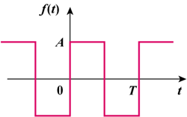 | 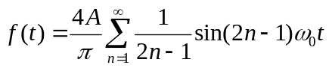
2. Sawtooth wave
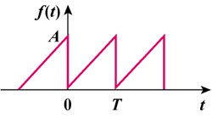 | 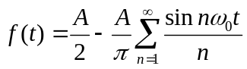
3. Triangular wave
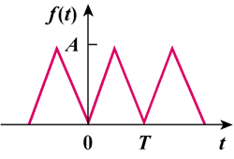 | 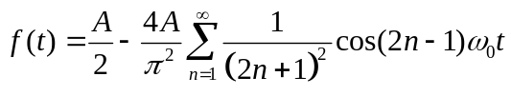
4. Rectangular pulse train
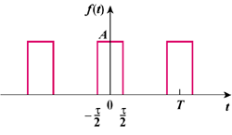 | 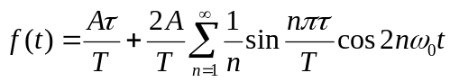
5. Half-wave rectified sine
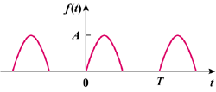 | 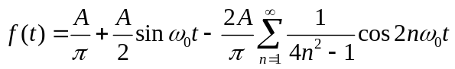
6. Full-wave rectified sine
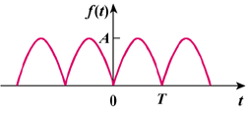 | 